Posted 10/03/2012 at 12:36 pm by JAV

Town Hall Building Committee

DRAFT Agenda
Town Hall Meeting Room
Tuesday, October 9, 2012
7:00 PM

- Public Comment

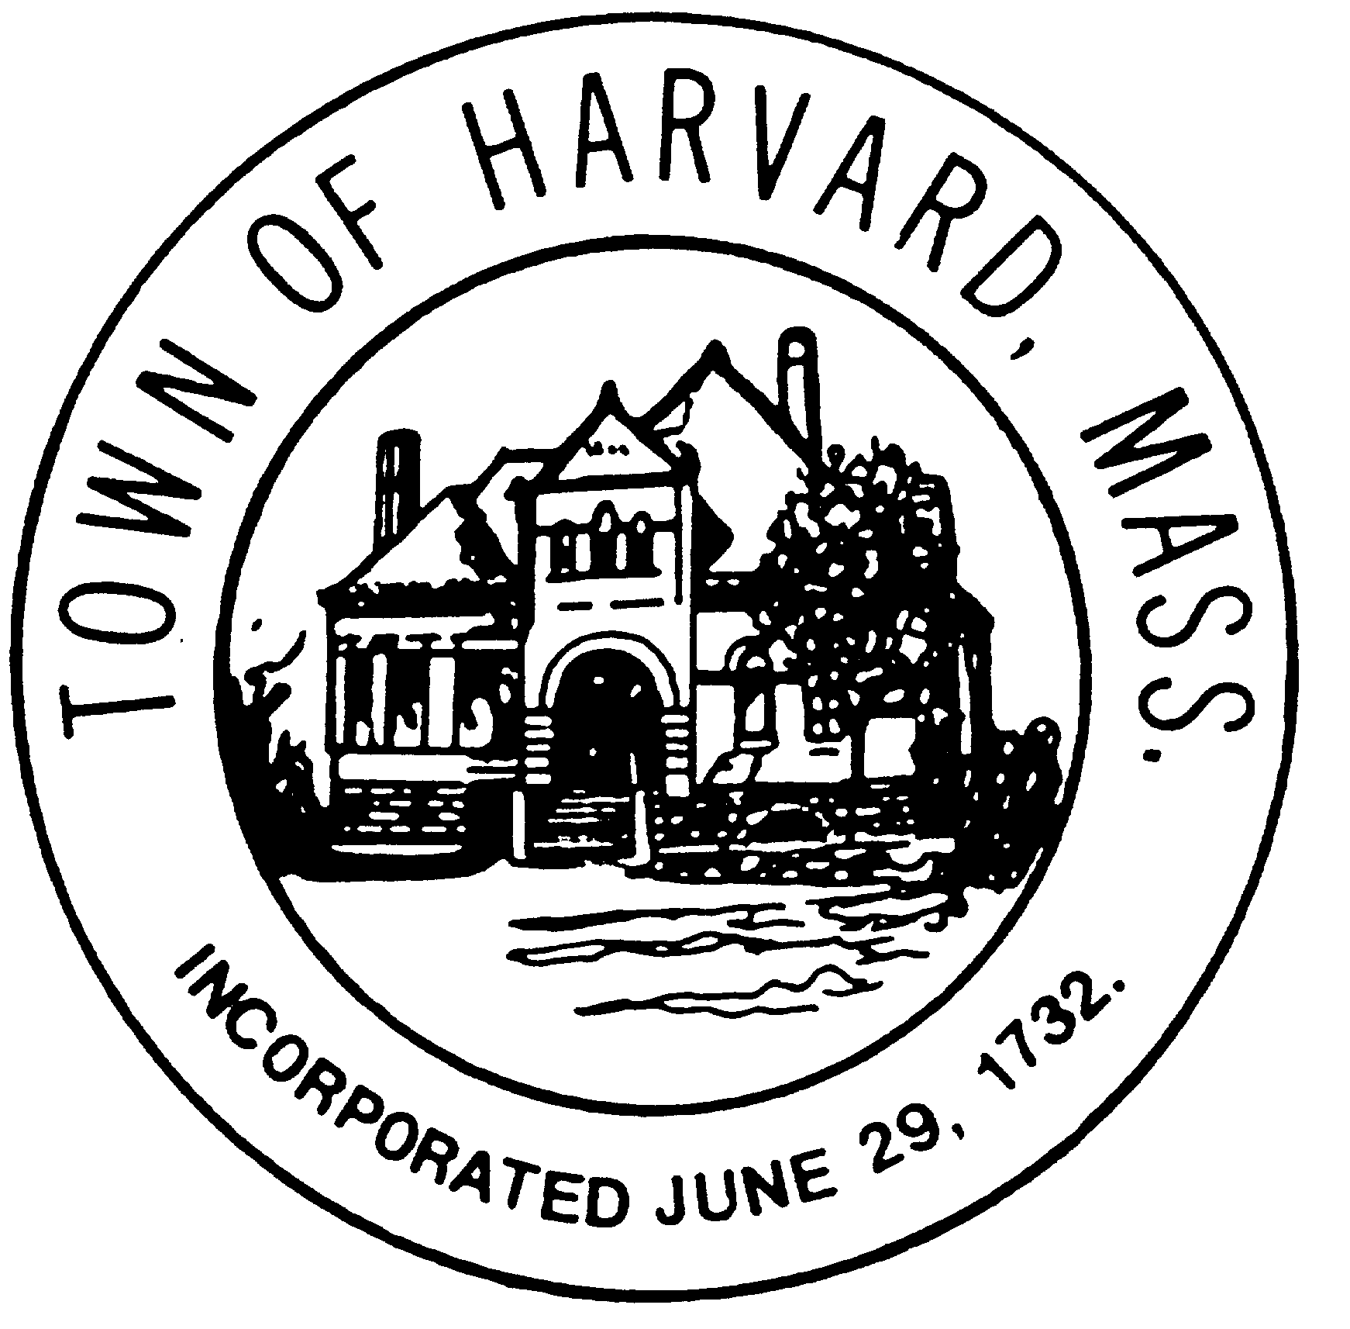
- Approve minutes

- Approve invoices

- Discussion of draft project schedule and budget - John

- Status of design development - Drayton

- New business

